**Honeycomb Bravo Inspired Modular HES Throttle Quadrant for Flight Simulation**

**(Build Guide)**

## Introduction

I am new to the flight simulation hobby, 3D printing, and CAD design, so please be patient with me. I decided to create my own throttle quadrant to enhance my immersive experience. This is intended for flight simulation enthusiasts who might find this useful.

## Features

* Simple design, featuring no complicated gears and very few 3D-printed parts.
* Friction is provided by a damping grease (Nyogel 767a or an alternative, such as the Chinese XY-2 damping grease), and the feel is almost hydraulic. Additional friction is provided by ball plungers that also act as detents.
* Modular, you can build one or build six!
* Uses Hall effect sensors to determine the position of the throttle and toggle switches, so you can map the axes to throttle, prop, mixture, etc., and the buttons to enable reverse thrust, for example
* It will appear as a joystick with axes and button switches in Windows and can be used for flight simulators such as MSFS 2020/2024 and X Plane
* There is a detent near the bottom, and below this detent, the lever position is no longer detected, but if you pull it down to the end, it will toggle a Hall effect switch (every time you pull the lever down, the switch will trigger on and off). I think this is how the Saitek/Logitech throttle quadrant works.
* Uses Raspberry Pi Pico (RP2040) as the microcontroller unit (MCU). One MCU can support up to 4 quadrants. If you need to build more than 4 quadrants, additional MCUs are required
* Optional: Up to an additional 16 buttons/switches can be connected to one MCU, which can be used for functions such as taxi lights, landing lights, gear up/down, etc.

## Bill of Materials

Besides a 3D printer and filaments (I printed mine with PLA), you will need:

* TLV493D Hall effect sensors (1 per quadrant). You can purchase them from here, or I will provide a Gerber file later to order them from JLCPCB.  
  <https://electroniccats.com/store/tlv493d-croquette/>
* A3144 Hall effect sensors (1 per quadrant)  
  <https://a.co/d/5zRXY3j>  
  <https://www.aliexpress.us/item/3256808061811784.html>
* 6802 ball bearings (2 per quadrant):  
  <https://a.co/d/fYThaC8>  
  <https://www.aliexpress.us/item/3256805848724629.html>
* M6 x 12mm Spring Ball Plungers (2 per quadrant)  
  <https://a.co/d/ewhuE3q>  
  <https://www.aliexpress.us/item/3256803247984132.html>
* Raspberry Pi Pico (RP2040). One RP2040 can support 4 quadrants. If you need to build 6 quadrants, for example, you will need two RP2040s.  
  <https://a.co/d/7AnGSWk>  
  <https://www.aliexpress.us/item/3256810023960508.html>
* Damping grease (Nyogel 767a or alternative)  
  <https://a.co/d/0ROj3E0>  
  <https://www.aliexpress.us/item/2255800028623438.html> (Note: I have not tried this one, but some reviewers say it is quite effective as well)
* Set of M3xD5xL4mm Heat Set Inserts  
  <https://a.co/d/bVl7WV7>  
  <https://www.aliexpress.us/item/3256809091759411.html>
* M3 Countersunk screws (different lengths)  
  <https://a.co/d/6a7sqof>  
  <https://www.aliexpress.us/item/3256806835027966.html>
* 6mmx3mm N52 Neodymium magnets (3 per quadrant, 5 per quadrant if you want to have magnets to hold the lever and the throttle/prop/mixture handle)  
  <https://ebay.us/m/fuZbeW>
* 10K ohm resistors (2 per quadrant)

## Printing Guide

All parts should fit a standard Ender 3-type 3D printer (256 mm x 256 mm x 256 mm). I printed mine with a Sovol SV08, which has a larger print volume of 350mmx350mmx350mm

Recommended print settings:

* Rafts: No
* Supports: Yes
* Layer Height: 0.2 mm
* Infill: 20%
* Filament Material: PLA, PETG, PLA+

Note: It is recommended to print the parts on their side so that the circles (e.g., bearing placement areas) are not distorted. Please see examples below:

**Main Body Left.step**

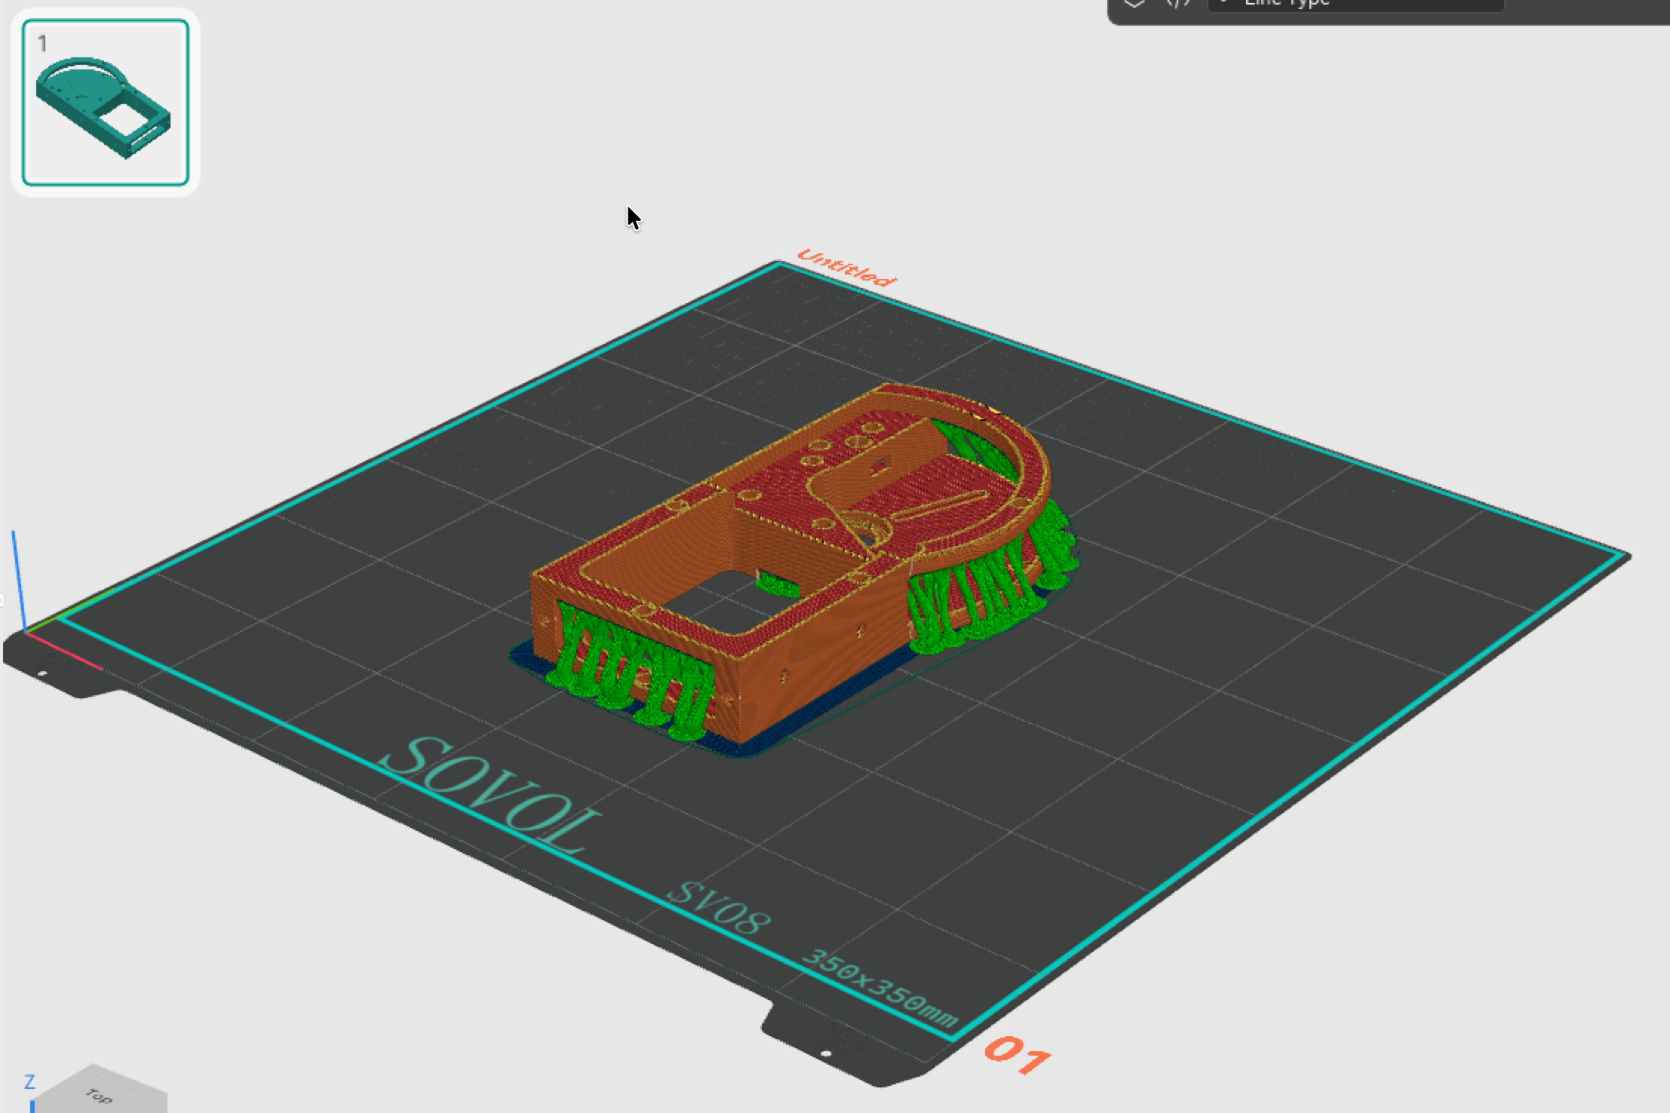

**Main Body Right.step**

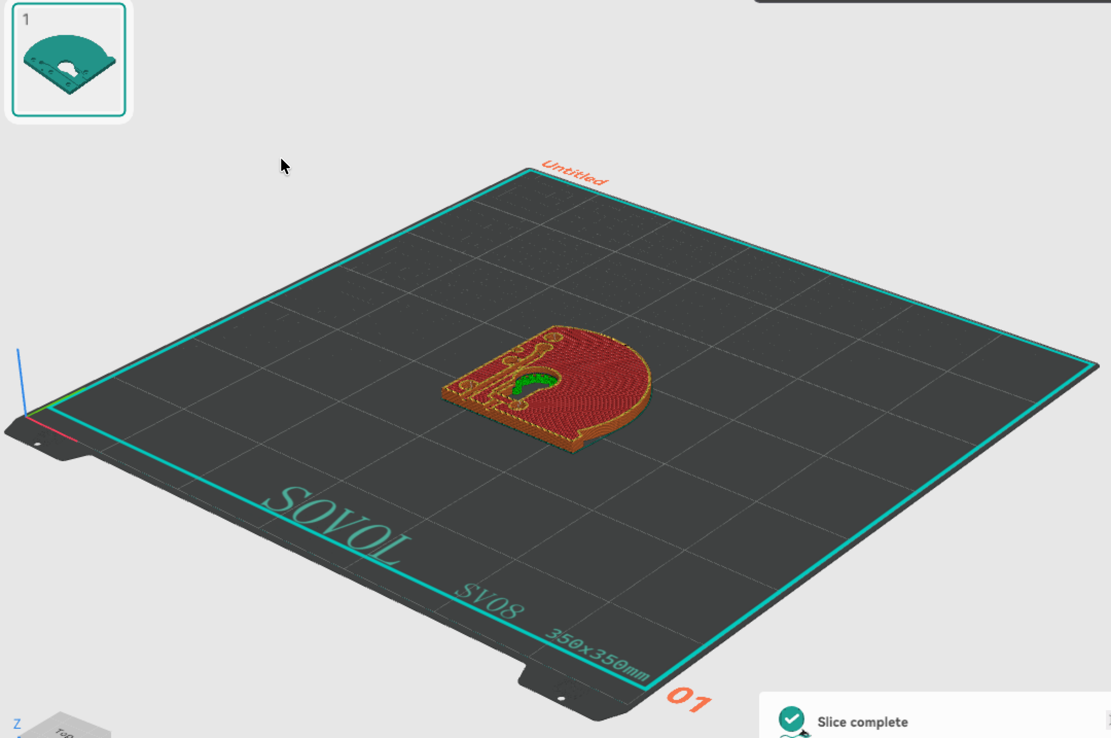

**Levers and Handles (Lever.step, Throttle.step, Mixture.step, Prop.step)**

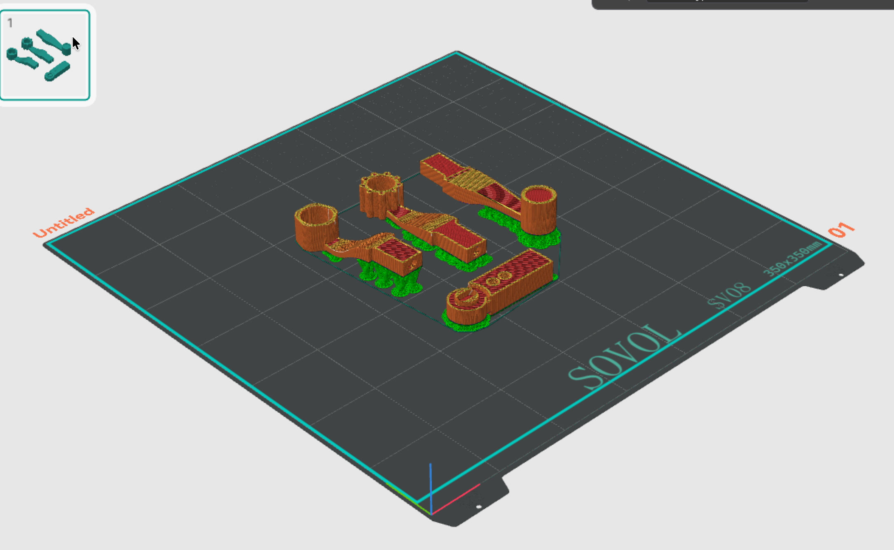

## Build Guide

For more details on how the different parts fit together, please see the **Throttle Quadrant Assembly.step** and **Throttle Handle Assembly.step** files

1. Remove all supports and clean up the 3D prints.
2. Sand lightly the surfaces below of the Main Body Left.step and Main Body Right.step to remove the layer lines. This will prevent the grinding noise when the detent plungers push against the 3D prints.

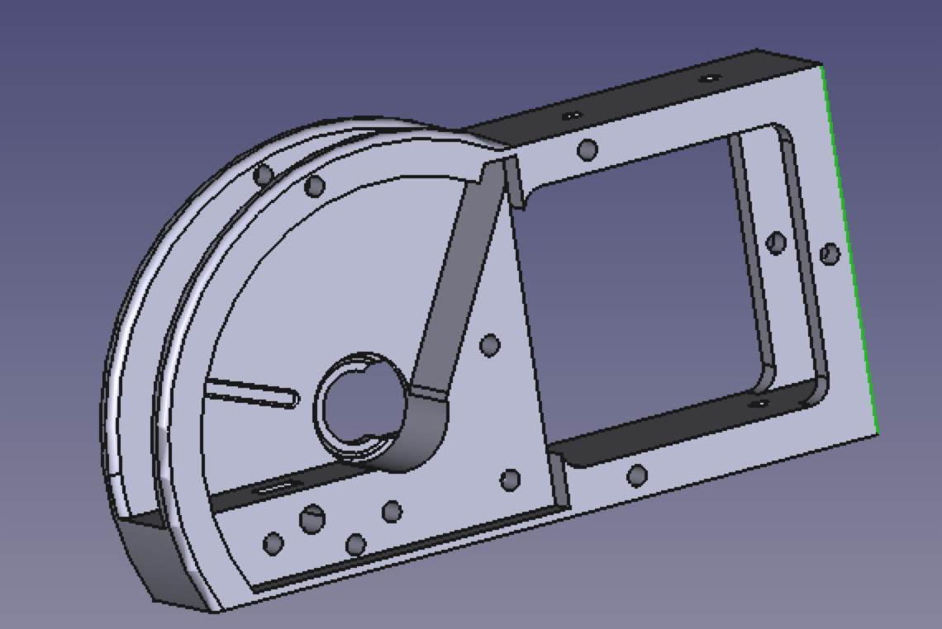

Lightly sand this area

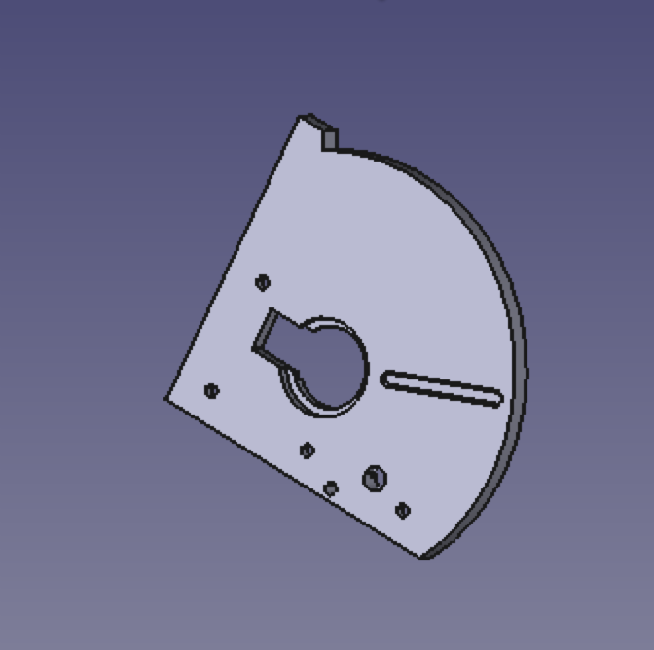

Lightly sand this area

1. Insert the M3 heat-set inserts into the holes below. If this is the right-most or left-most quadrant, also insert the M3 heat sent inserts in the other holes so you can attach the end covers



1. Apply a thin coat damping grease (Nyogel 767a or alternative) to the surface areas below.



Apply damping grease



Apply damping grease

1. Attach one of the 6802 ball bearing to the Main Body Right.step part

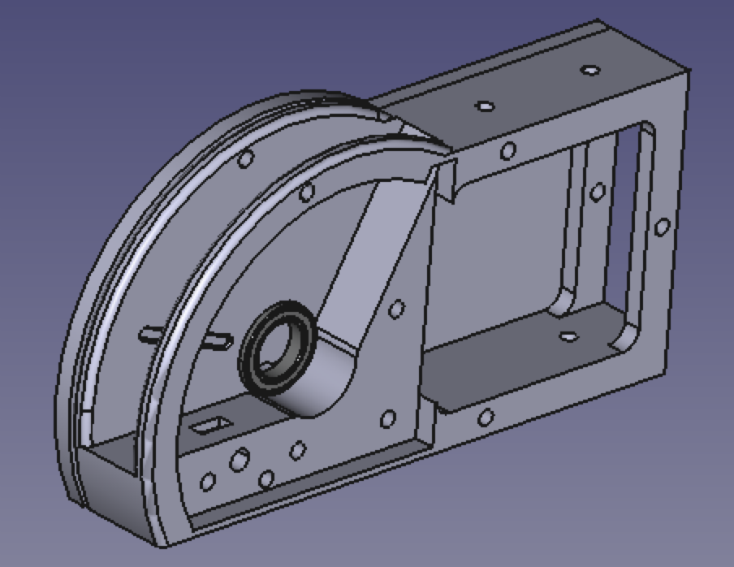

6802 ball bearing

1. Insert the A3144 Hall Effect Sensor (HES) into the square recess below. **Note: The A3144 should already be wired up (refer to the wiring guide later in this document)**, and thread the wires through the hole and route them through the wire channel recess. The curved side (the side with printed letters) of the A3144 sensor should be facing up. If needed, secure the A3144 with a light dab of hot glue (I found it not necessary)

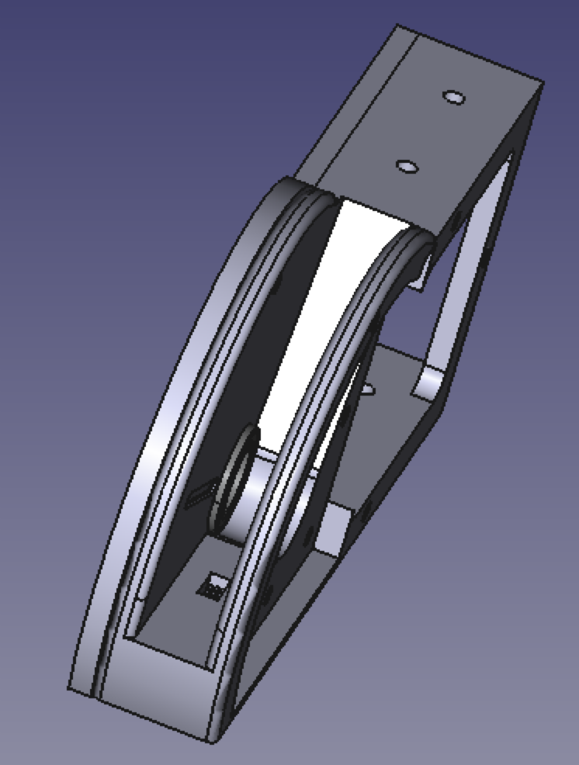

A3144 HES

1. Secure the N52 6 mm x 3 mm neodymium magnets to the lever with hot glue. Please take particular attention to the polarity of the magnets.

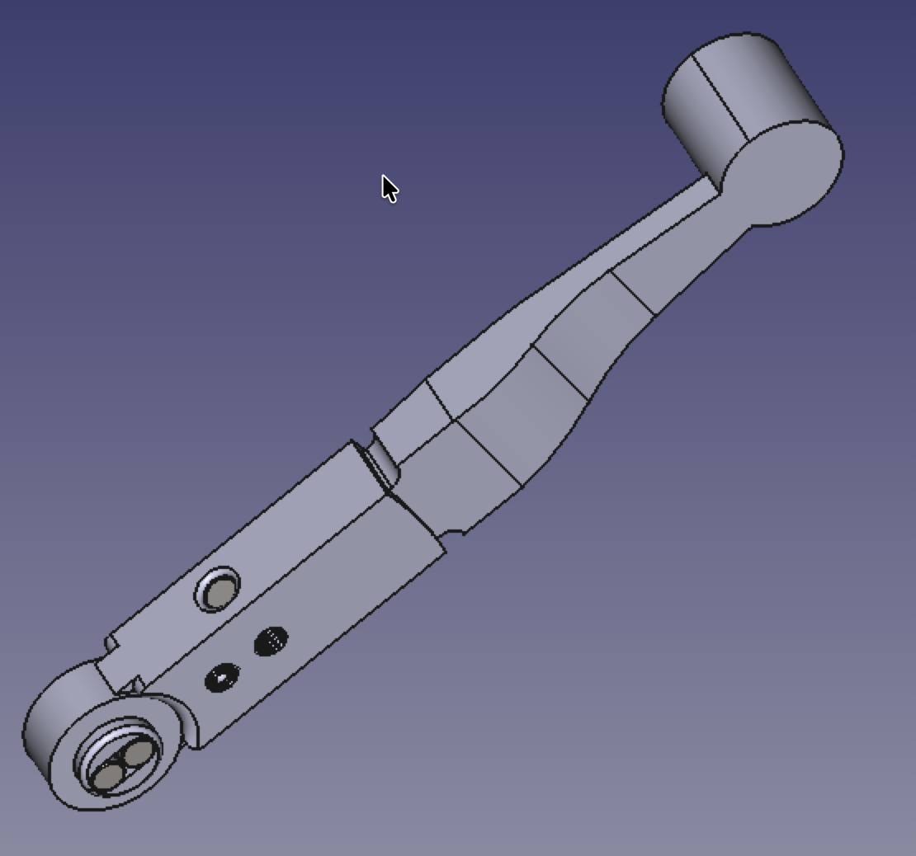

M6 x 12 mm Spring Ball Plungers facing opposite directions

Magnet South Pole

Magnet North Pole

Magnet South Pole

‘

Note: To determine the polarity of the magnet, you can use KJ Pole ID in your smartphone app (Iphone only)

<https://apps.apple.com/us/app/kj-pole-id/id1323248335>

<https://www.kjmagnetics.com/blog/magnet-pole-detector-app?srsltid=AfmBOooUKxkKrpdQ3W3sx5v4dvxNEieNm_Vk7YbFZn1JEUP7y4BIYaNd>

Or you can wire up an A3144 Hall Effect Sensor as a magnetic pole detector. The sensor will activate if the **South Pole** is placed near it

<https://www.youtube.com/shorts/ecc37npDjDA>

1. Insert the two M6 x 12 mm Spring ball plungers in the holes below. The amount of protrusion can adjust the tension and the strength of the detent. They should be facing opposite directions (see picture above)
2. Insert the lever assembly into Main Body Left

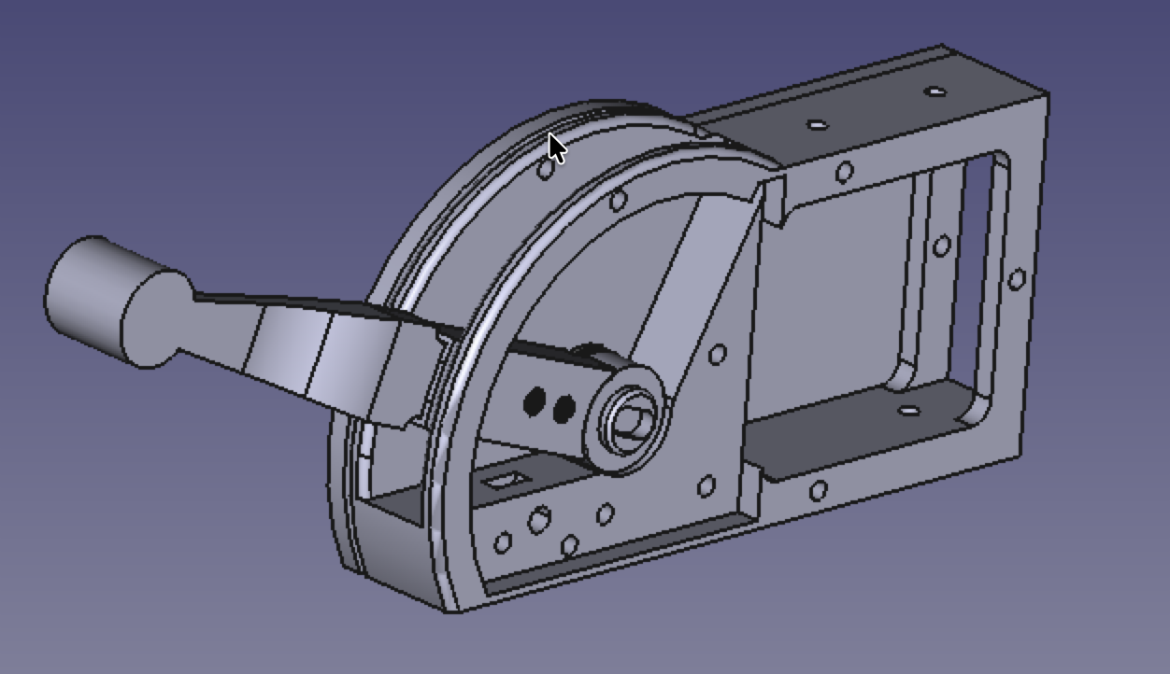

1. Secure the TLV493D Hall Effect sensor to Main Body Right with light dabs of hot glue. **Note: The wires to the TLV493D should already be connected** (refer to the wiring guide later in this document). Route the wires through the wire channel recess.

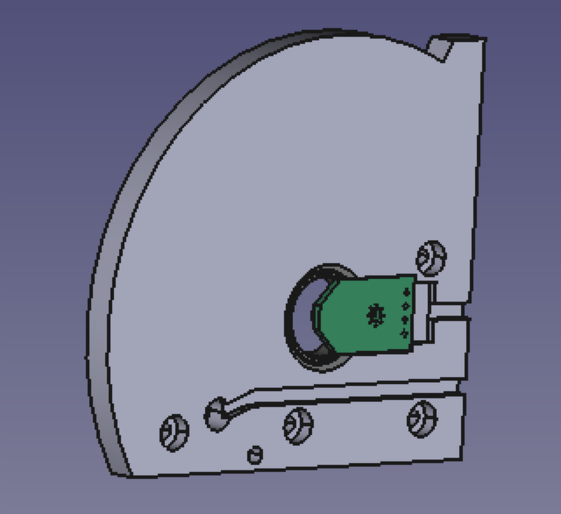

TLV493D Sensor

1. Insert the other 6802 ball bearing to the Main Body Right

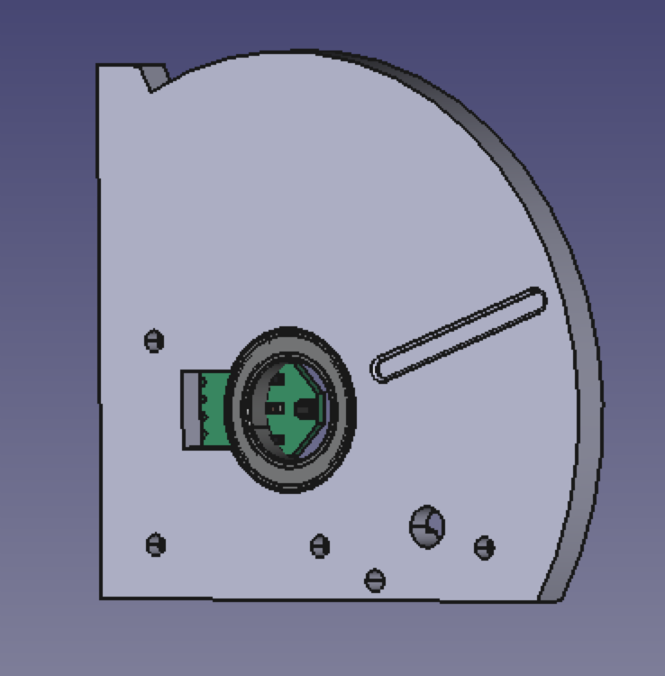

6802 ball bearing

1. Secure the Main Body Right assembly to the Main Body Left assembly with M3 flathead screws.

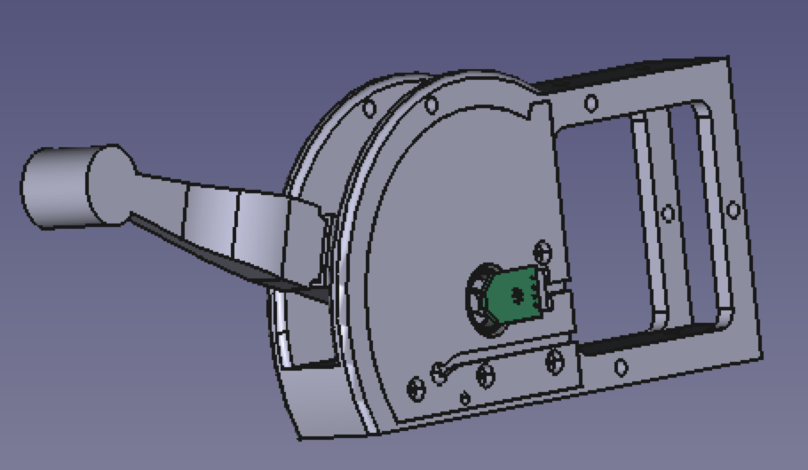

1. Optional: Attach the Left Side Cover and/or Right Side Cover with M3 flathead screws.

## Electronics and Wiring Guide

**Important Note: One Raspberry Pi Pico (RP2040) can support up to 4 quadrants and 16 switches (optional)**

1. For each RP2040, 10K pull-up resistors need to be connected between pin 4 and +3V3, and pin 5 and +3V3 (see diagram below)

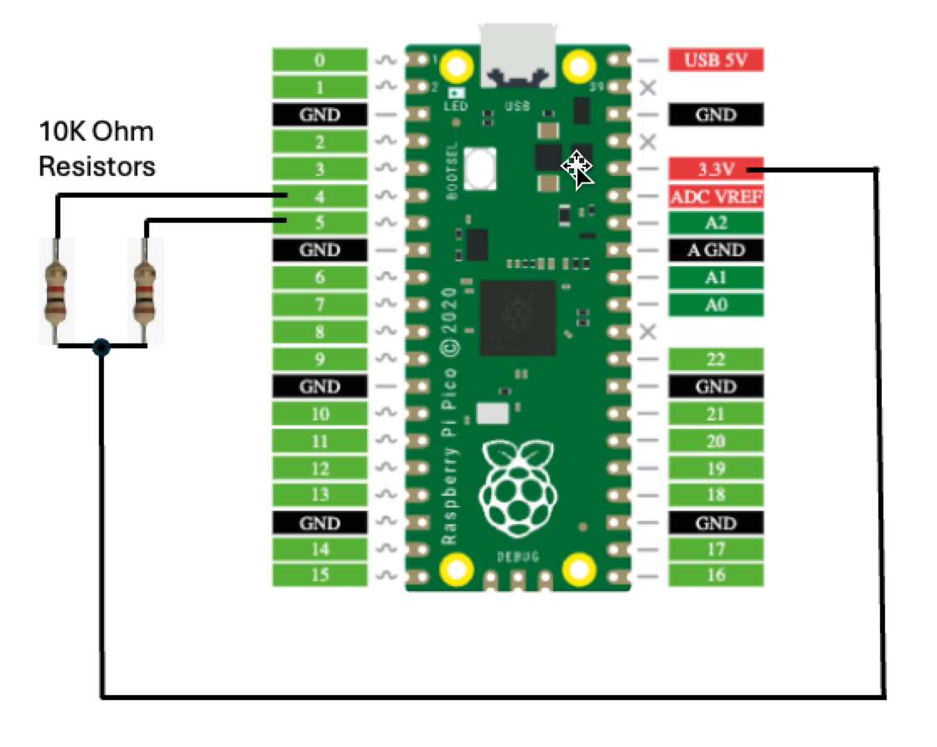

1. The pull-up resistors (R2 and R3) on all the TLV493D board needs to be removed/desoldered. Alternatively, you can order the TLV493D board from JLCPCB (Gerber files linked in the Bill of Materials above) and do not place these resistors when configuring the bill of materials.

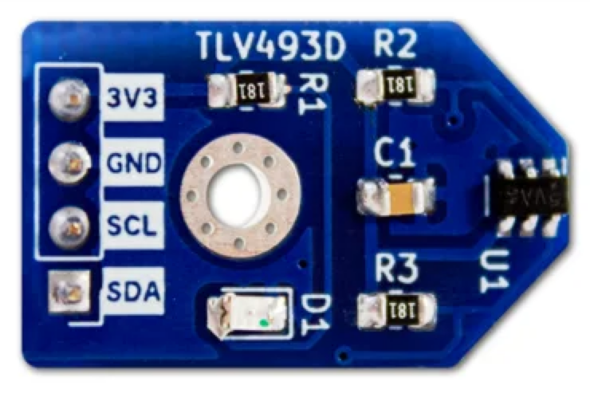

Remove/desolder these resistors

1. Refer to the table below to connect the TLV493D board and the A3144 Hall effect sensor to the RP2040.

Note: A3144 pinout is below

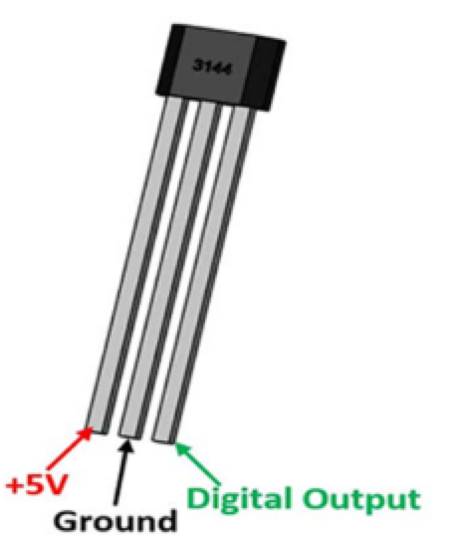

|  |  |  |
| --- | --- | --- |
| **Sensor** | **Sensor PIN** | **RP2040 PIN** |
| TLV493D Sensor 1 | 3V3 | 0 |
| GND | GND |
| SCL | 5 |
| SDA | 4 |
| TLV493D Sensor 2 | 3V3 | 1 |
| GND | GND |
| SCL | 5 |
| SDA | 4 |
| TLV493D Sensor 3 | 3V3 | 2 |
| GND | GND |
| SCL | 5 |
| SDA | 3 |
| TLV493D Sensor 4 | 3V3 | 3V3 |
| GND | GND |
| SCL | 5 |
| SDA | 4 |
| A3144 Sensor 1 | +5V | USB 5V |
| GND | GND |
| Digital Output | 6 |
| A3144 Sensor 1 | +5V | USB 5V |
| GND | GND |
| Digital Output | 7 |
| A3144 Sensor 1 | +5V | USB 5V |
| GND | GND |
| Digital Output | 8 |
| A3144 Sensor 1 | +5V | USB 5V |
| GND | GND |
| Digital Output | 9 |

**Optional:** Additional 16 buttons/switches can be connected one RP2040 to use for taxi lights, landing lights, gear up/down, etc. Connect 1 PIN of the switch/button to ground and the rest of the switches can be connected to the RP2040 PINs according to the table below:

|  |  |
| --- | --- |
| **Switch/Buton** | **RP2040 PIN** |
| 1 | 10 |
| 2 | 11 |
| 3 | 12 |
| 4 | 13 |
| 5 | 14 |
| 6 | 15 |
| 7 | 16 |
| 8 | 17 |
| 9 | 18 |
| 10 | 19 |
| 11 | 20 |
| 12 | 21 |
| 13 | 22 |
| 14 | 26 |
| 15 | 27 |
| 16 | 28 |

## Flashing The Firmware

1. Download the firmware file from the Github repository (link below) under the folder “Firmware”

<https://github.com/savesabanal01/3S-Throttle-Quadrant> to your local folder. The file is called “**3SThrottleQuadrant.uf2**”

1. Plug the RP2040 to your computer while holding down the BOOTSEL button to put the RP2040 into bootloader mode.
2. Drag and drop the 3SThrottleQuadrant.uf2 firmware file to the “RPI-RP2” drive. This will flash the firmware to the RP2040.

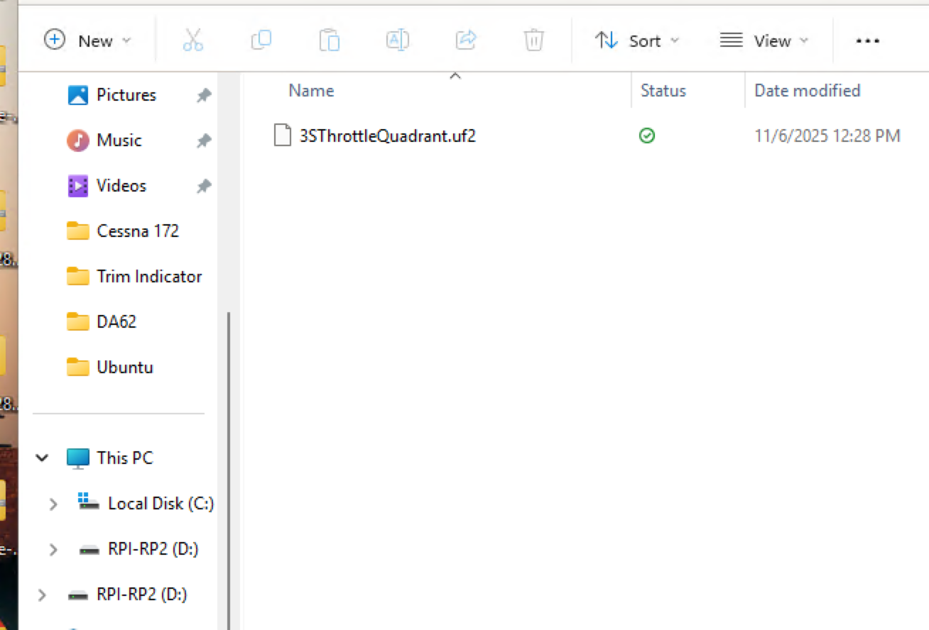

Drag and Drop

It will then appear as a joystick device called “3S Throttle Quadrant” which you can then configure for MSFS 2020/2024, X Plane, etc.

